**Christopher King**

**2018141521058**

**Mechanical Design 1**

**Class Section 01**

**10/16/2020**

# **Problem 1**



**Solution:**

For this question, we are asked to determine what the length of the bar must be.

# **Problem 2**

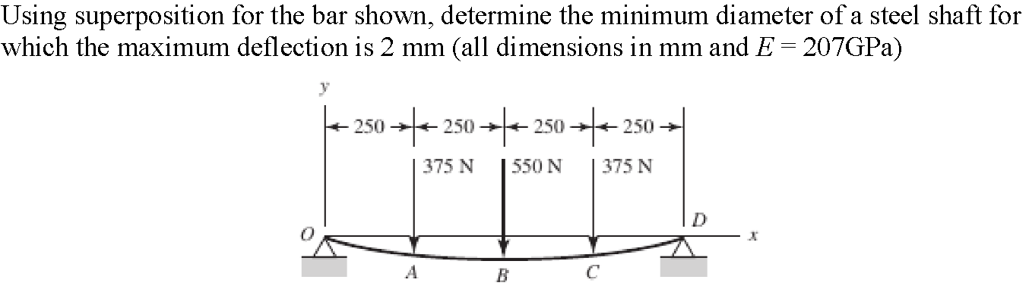

**Solution:**

For this question, we are asked to, determine the minimum diameter of a steel shaft for which the maximum deflection is 2 mm (all dimensions in mm and E = 207GPa) using superposition for the bar shown.

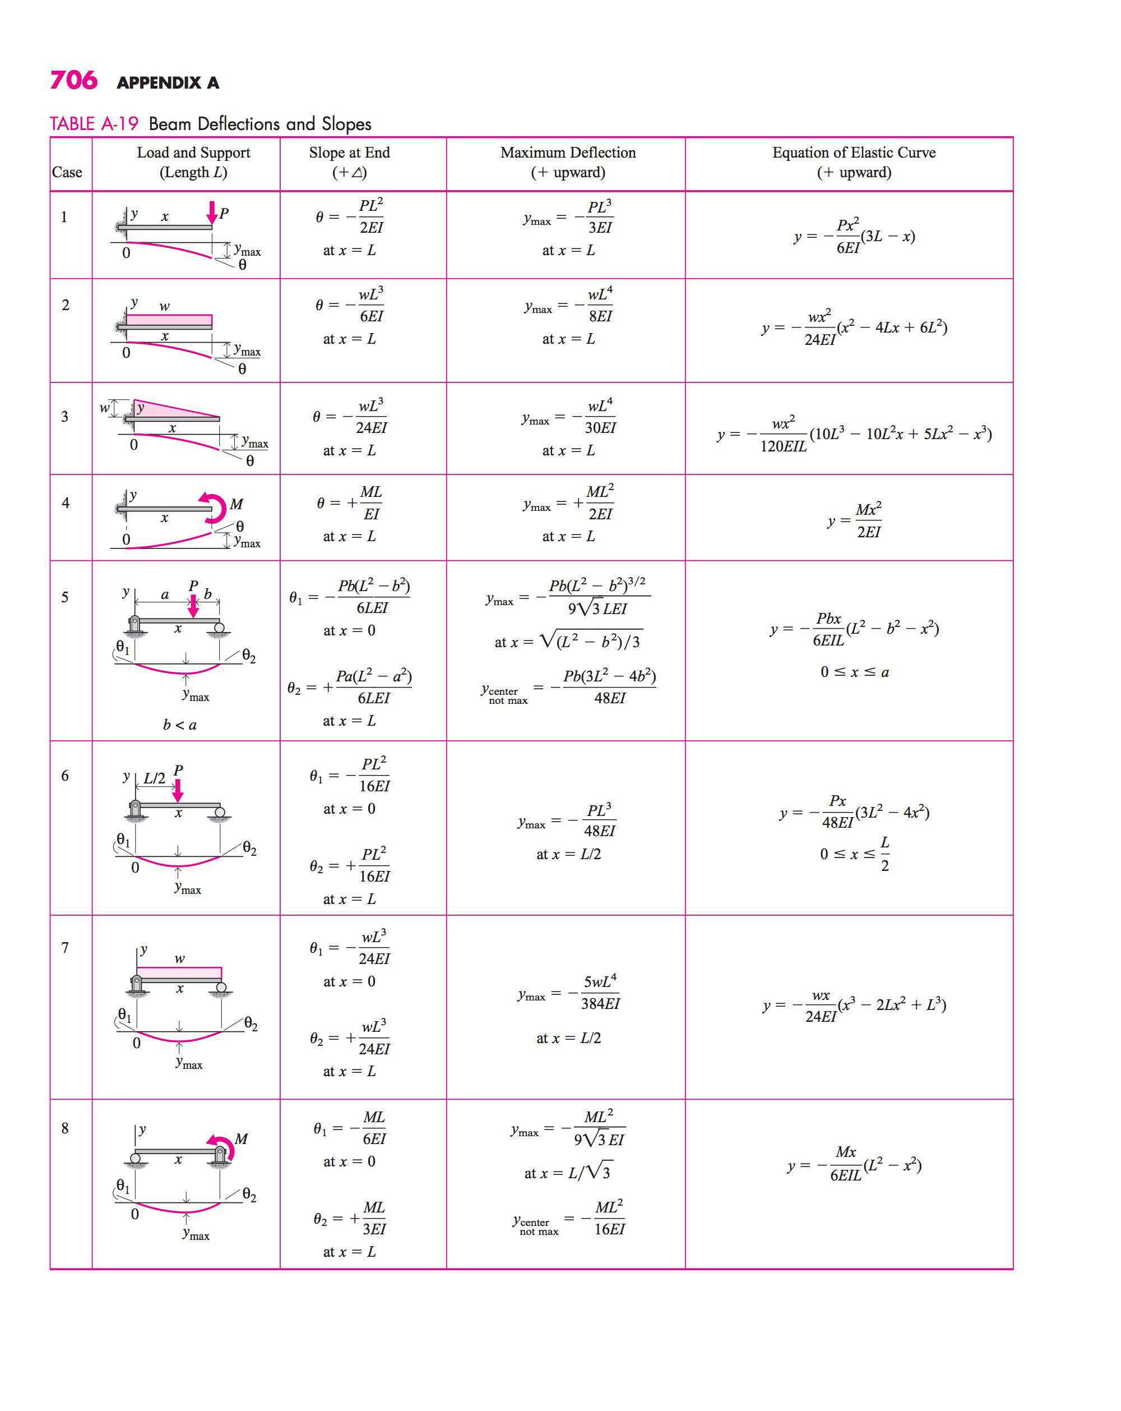

From the picture above, I can know that

# **Problem 3**

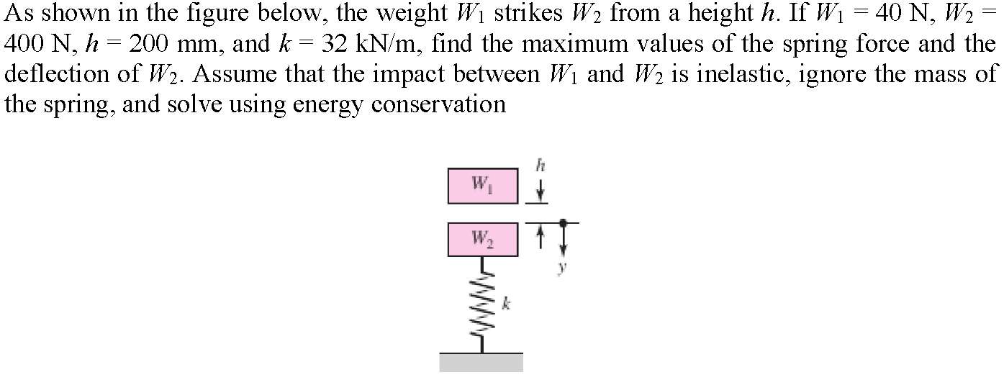

**Solution:**

For this question, we are asked to find the maximum values of the spring force and the deflection of .